LIN Slave 4 Module Design

History
Issue status  (Index) | Maturity/Date  (draft/invalid/valid)  (dd-mmm-yyyy) | Author  Department | Check/Release  Department | Description
1.0 | Draft  05-Aug-15 | Alexis Garcia / Roberto Palos | Alexis Garcia / Roberto Palos | Creation of the document.
1.1 | Draft  06-Aug-15 | Alexis Garcia / Roberto Palos | Alexis Garcia / Roberto Palos | Addition of some diagrams, work still in progress
1.2 | Draft  06-Aug-15 | Roberto Palos | Alexis Garcia / Roberto Palos | Added LIN state machine (figure 5).
1.3 | Draft  06-Aug-15 | Alexis Garcia | Alexis Garcia / Roberto Palos | Added the hyperlink to the LED design document

Table of Contents
1 Purpose 3
2 Definitions and abbreviations 3
3 Realization constraints and targets 3
4 SW Conceptual design 3
5 SW Component internal breakdown 4

Purpose
This Document has been created to detail the design of the LIN Slave number 4 modules, this slave shall control a led integrated in the TRK-MPC5606B Board, based on the LIN protocol version 2.0 in a network with a Master and another 3 slaves named as Slave 1, Slave 2, Slave 3 and Slave 4 respectively.

Definitions and abbreviations
Definitions
LIN  Master  Slave | Protocol of Communication (local interconnect network)  The node who controls the LIN network  The node who response the petitions of the master in the LIN network
HAL | Hardware Abstraction Layer
MAL | Microcontroller Abstraction Layer
APP | Application Layer

Abbreviations
References
N° | Document name | Reference
1 | Traceability Matrix LIN Slave 4 | Traceability Matrix LIN Slave 4
2 | LIN Module Requirements | LIN Module Requirements

Realization constraints and targets

The goals and purposes to realize this module is to provide a LIN network and with this a method based on the Master and slave architecture able to communicate with a master on the net , with this , it will be able to control a led functionality , this includes turning on a led, turning off a led , toggling a led and also sending a response to the master with an number (for this purpose based on the team number), and an array of characters (the initial letters of our names).

SW Conceptual design
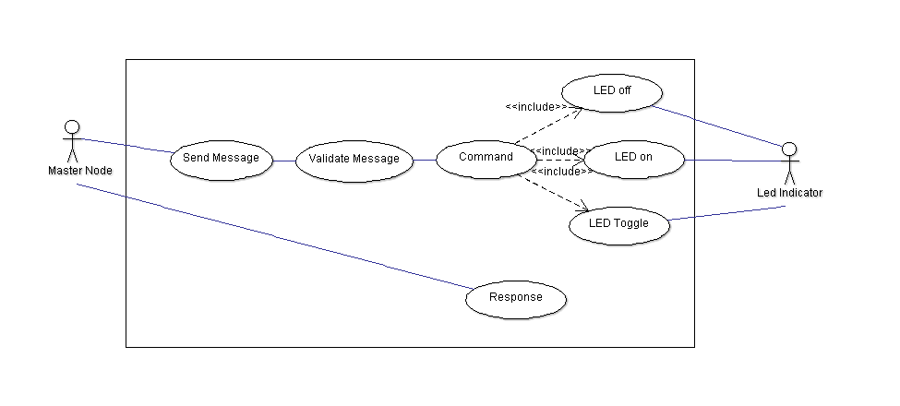
Figure 1 Use Case Diagram for LIN Slave 4

Master Node: This is the node that controls the transmission and flow of data in the LIN network , in this case, the master node Is capable of send a message and request for an LED ON request, this will turn on the led indicator, also can request and LED off , this will turn off the led indicator, and finally the LED toggle request is for the led turn on and off periodically.
Send Message: This represents the capability of the master node to send a message for the slave module.
Validate Message: This case represents the ability of the slave module to filter the messages that this module cans only response and ignore the message sent to another slave.
Command: This represents the case where the master sent a command for the led indicator, explained above.
Response: This is the response sent to the master node via the slave module, it can respond with a variety of status like LED is ON or ACTIVE.
Led Indicator: This represents the led in the TRK – MPC5606B board.

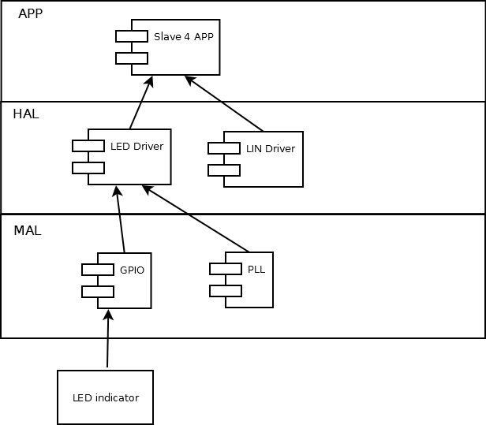
Figure 2 Components Diagram for LIN Slave 4

The architecture chosen for this module is based on an layer implementation, in the MAL layer we have the GPIO and PLL drivers, to provide access to the pins and registers of the microcontroller, the HAL layer provides two modules, one for the LED indicator control, LED Driver, capable of turning on, off and toggling the led, and one for the LIN network control and communication, this is included in the HW on the board. Finally we have the APP layer, where the Slave is present, this will handle the messages sent by the Master and provide control over this, also sent responses when is required by its master.

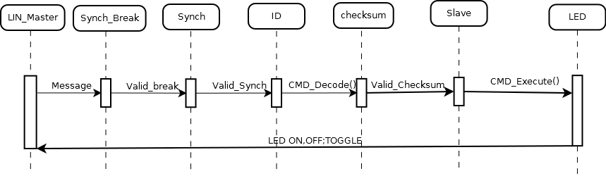
Figure 3 Sequence Diagram for LIN Slave 4

The sequence for the slave, the master send a message with a petition, after that the slave must check the fields of the message to validate the message, like the sync break , the sync field and check if the ID message is for the slave 4, also check for the validity of the message with a checksum, after that the slave execute a command an turn on /off/ toggle the led

SW Component internal breakdown
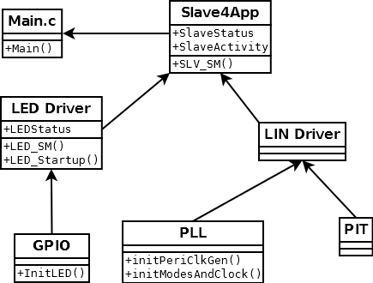
Figure 4 Class Diagram for LIN Slave 4

For more information of the LED Design Document, follow the document link DSD_Led_State_Machine.doc

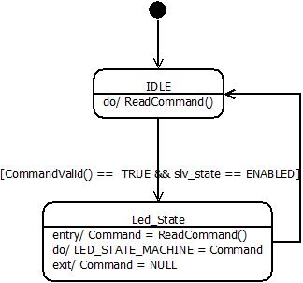

Figure 5 State Machine for LIN Slave 4
IDLE: The IDLE state waits and read all commands in the LIN bus but only can leave this state when a valid command is received.
Led_State: This state convert the command received from the IDLE state to a valid state in the LED_STATE_Machine changing his state and then return to IDLE state to wait for a valid command.

Functional Decomposition

Function Description and Dynamic Behavior

Function <Type> <function name> (type par 1, .., type par n)

Description | Brief description of the function behavior and useful remarks
Parameter 1  <input| output| inout> | Give an explanation if the parameter shall be checked by the user, or if a check is implemented in the function here
Parameter 2..n
Return Value
Precondition | e.g. Function can only be called in a certain state, SW component is initialized  Relation between input parameters where applicable (Input for Module Test)
Post condition | e.g. specific State change e.g. car is locked, EEPROM Values written,  Relation between output parameters where applicable
Error Conditions

Dynamic Behavior
State Chart¹, Flow Chart¹
¹ Preferred
In this document, the dynamic behavior shall be designed on an abstract level showing the principle workflow of a function. Do not show the detailed implementation to ensure that the design description can be maintained with a reasonable effort. The target is not to show the complete detailed implementation 1:1.
The detailed design shall reflect in detail what a function is doing from a black box view. The internal details are useful on an abstract, but not very detailed level.
If the function is not complex a short textual description might be sufficient and a graphical description is not needed.
Symbol and function names shall be self explaining.
The link to the implementation may be provided by using the same names as in the design or by a comment showing the full name followed by the declaration showing the implementation.

Function <Type> <function name> (type par 1, .., type par n)
Description | Brief description of the function behavior and useful remarks
Parameter 1
<input| output| inout>
Parameter 2..n
Return Value
Precondition | e.g. Function can only be called in a certain state, SW component is initialized  Relation between input parameters where applicable (Input for Module Test)
Post condition | e.g. specific State change e.g. car is locked, EEPROM Values written,  Relation between output parameters where applicable
Error Conditions

Dynamic Behavior
State Chart¹, Flow Chart¹, Nassi Shneiderman
¹ Preferred
In this document, the dynamic behavior shall be designed on an abstract level showing the principle workflow of a function. Do not show the detailed implementation to ensure that the design description can be maintained with a reasonable effort. The target is not to show the complete detailed implementation 1:1.
The detailed design shall reflect in detail what a function is doing from a black box view. The internal details are useful on an abstract, but not on a very detailed level.
Symbol and function names shall be self explanatory.
The link to the implementation may be provided by using the same name as in the design or by a comment showing the full name followed by the declaration showing the implementation.

Macros

Only complex macros shall be described here. A complex macro is longer then one line or has more then one parameter or command. A complete description of all macros shall be done by code comments.
Be aware: macros shouldn’t be part of the interface: Don’t use macros at interface level!
If you still think you need macros: document them like functions.
Internal Interfaces
For internal interaction a data flow and/or a message sequence chart shall be provided. If the Static Function Tree already contains a data flow description then just reference it

SW module global variables
Where shared variables can not be avoided, a risk analysis is mandatory.
Name | Type | Memory section | Description | Shared
Klstrg_status | T_UBYTE | NON_INIT_RAM | Status of terminal control | X

Design solutions for general features
It should describe detailed design solutions for general features of our products. i.e ”Layer Programming”

SW Component integration

Integration context / constraints
Tbd: help text

Include files
Slave.h , Led Driver.h, LIN.h

Initialization
e.g. Sequence Chart for initialization
All function bellow shall be called on initialization
Call Order | Service | Call constraints linked to an other module
1 | BCM_Warning_Output_Init_Function | After EEPROM init

Interrupts
If described in the SW Architecture Document, just put the reference here.

Real time scheduler task
If described in the SW Architecture Document, just put the reference here.

Other entry points
Name | Service | Task level

